

Faculty of Science and Technology

BSc (Hons) Games Programming

May 2019

Development of a Mobile Game utilising Stimuli

to Improve Human Reaction Time

by

Jake Walder

**DISSERTATION DECLARATION**

This Dissertation/Project Report is submitted in partial fulfillment of the requirements for an honours degree at Bournemouth University. I declare that this Dissertation/ Project Report is my own work and that it does not contravene any academic offence as specified in the University’s regulations.

**Retention**

I agree that, should the University wish to retain it for reference purposes, a copy of my Dissertation/Project Report may be held by Bournemouth University normally for a period of 3 academic years. I understand that my Dissertation/Project Report may be destroyed once the retention period has expired. I am also aware that the University does not guarantee to retain this Dissertation/Project Report for any length of time (if at all) and that I have been advised to retain a copy for my future reference.

**Confidentiality**

I confirm that this Dissertation/Project Report does not contain information of a commercial or confidential nature or include personal information other than that which would normally be in the public domain unless the relevant permissions have been obtained. In particular, any information which identifies a particular individual’s religious or political beliefs, information relating to their health, ethnicity, criminal history or personal life has been anonymised unless permission for its publication has been granted from the person to whom it relates.

**Copyright**

**The copyright for this dissertation remains with me.**

**Requests for Information**

I agree that this Dissertation/Project Report may be made available as the result of a request for information under the Freedom of Information Act.



Signed:

Name: Jake Walder

Date: 02/06/2019

Programme: BSc GP

Acknowledgements

Firstly, I would like to give a large thank you to my primary supervisor, Vedad Hulusic for his continuous guidance and support throughout this project. Without his knowledge and help on this project, none of it would have been possible and so many considerations would have been missed. His influence on this project was invaluable and would not have met its full potential without it.

I would also like to thank my secondary supervisor and programme leader Fred Charles for his support and guidance that was given during the difficult times of this project.

Finally, I would like to thank my friends and family who supported me throughout this process, as without them I would not have completed this project.

# Abstract

The time we humans take to react to things is known as the human reaction, and it has a fundamental to any many activities. The speed of this reaction can often influence the severity of certain detrimental consequences. This project designs and implements three small games within a mobile application developed using Unity’s (2019) game engine, with the intention of improving the player’s reaction time. The development of the application is outlined, and the methods used to incorporate stimuli and response time testing is discussed. Testing was carried out after the completion of the application, and the resulting data evaluated; the conclusion was made that action video games can indeed improve the user’s reaction time.

# Contents

Abstract 3

Contents 4

Introduction & Objectives 5

Introduction 5

Aims 7

Objectives 7

Hypothesis 7

Background Theory & Design 8

Background Theory 8

Design Process Overview 9

Application Design 10

Shooting Game Design 10

Driving Game Design 12

Dodging Game Design 13

Development Methodology 15

Development Overview 15

Shooting Game Development 15

Driving Game Development 17

Dodging Game Development 18

Testing Methodology 20

Testing Overview 20

Controlling Variables 20

Expected Findings 21

Testing Results 22

Reaction Time Results 22

Age Influence on Results 25

Handedness Influence on Tap Position 26

Results Discussion 29

Reaction Time Evaluation 29

Handedness Evaluation 30

Results Evaluation 30

Conclusion 31

Application Evaluation 31

Project Analysis 32

Conclusion 33

References 34

Appendices 36

# Introduction & Objectives

## Introduction

A human response can alter the severity of any everyday situation, so it is important to keep the time of these responses as low as possible. Whether driving or playing a sport, the outcome of every reaction will be defined by both its speed and accuracy.

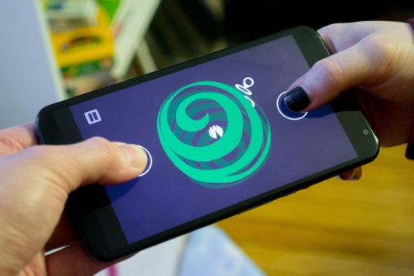It has been said that playing action video games *‘significantly reduces reaction times’* (Dye, Green and Bavelier, 2009). In order to prove this, participants played action games such as Call of Duty 2 (2005) and Unreal Tournament (1999), and their response times were tested after a period of use. These discoveries led to the motivation behind this project which is to create a series of three small games. These will require the player to react quickly, improving the speed of their responses over time. The games will be simple versions of popular action game types and features (i.e. driving and shooting) that demand fast and accurate responses. They will induce the reactions by displaying a stimulus on screen for the player to interact with, and then the reaction from the player will be recorded (from between the stimulus being displayed and the player’s reaction) by the game and saved to the device for later use. Action games are the optimal game type for improving response times due to their nature of fast paced gameplay, and requisite for quick decisions and actions by the player. Once the player has finished a game session, all of the response time readings will be output and then compared to any previous plays. This should show an increase in response time from the first play session of the game when compared to the last, which will then provide proof of video games’ ability to improve response times and accuracy.

There are various types of stimuli that cause reactions within games. Technology has the capability of using visual, auditory and tactile stimuli to produce a reaction from the user. Mobile phones are a great example of a device that can utilise all three (See Fig. 1 for an example of a mobile game), for instance notifications on a mobile phone can be reported in the form of visual information, auditory sounds and tactile vibrations to the user. For the sake of this project, only visual stimuli will be used to test the reaction times, as a study showed that the response to *‘tactile stimuli was significantly shorter’* (Ng and Chan, 2012), followed by auditory and then visual stimuli respectively. As visual stimuli are the slowest of the three to generate a response, this allows for the improvement of the reactions to be greater and clearer to analyse. Mobile phones will be the perfect platform to test these responses as they have an interactive touch screen, allowing for immediate response from the user that can be used within a video game scenario. This project will also test the concept of how decision making within a video game scenario can influence the speed of a response, as the three games will require an increasing amount of decision making to play.

Figure 1: A simple mobile phone game (Greenbot, 2015)

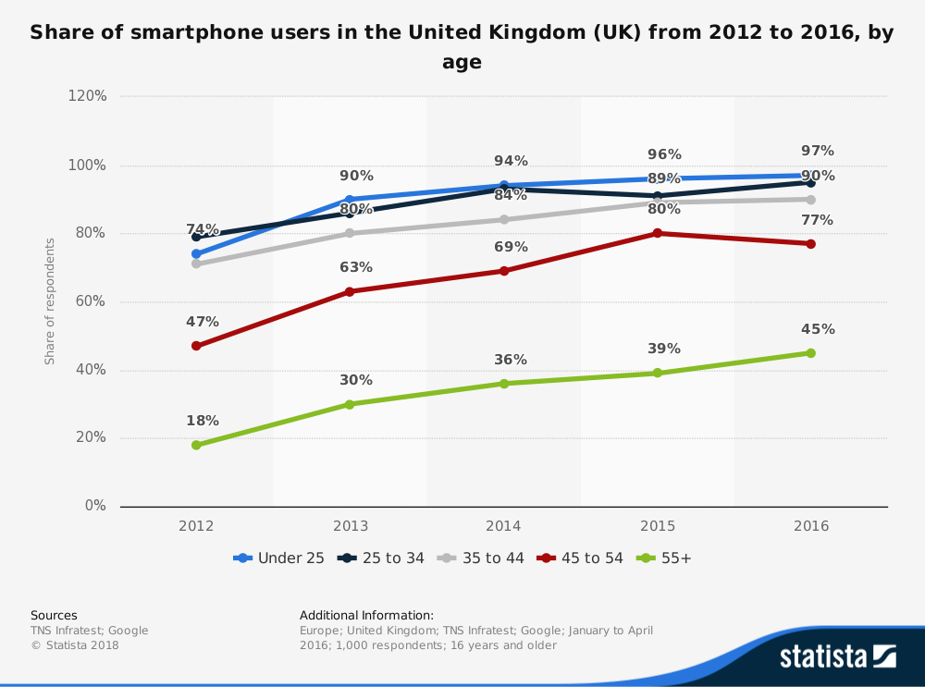Not only are mobile phones a great platform for these simple games, but they are also ideal for making these games very accessible to the public. There is a huge increase in the number of smartphones per capita; the population of smartphone users was at a rate of 75% of males and 73% of females in the UK in 2016, which means that the population of users increased by 21% and 25% respectively since 2012. (Statista, 2018). Fig. 2 below also shows the main age demographics of smartphone users and the growth of each group.

Figure 2: The percentage of smartphone users in the UK (Statista, 2018)

These games will be simple and accessible, yet retaining a challenging and entertaining factor, making the improvement of one’s reaction time enjoyable. This means that this project will enable both gamers and non-gamers to improve their response time for any reason they deem necessary, whether it’s to improve their ability in sports, driving, or video games.

## Aims

* The primary aim is to create a mobile application for Android using Unity (2018), consisting of three games that test response time.
* The secondary aim is to test multiple users’ response times over a set period, and compare the results to show any improvement of their response time.

## Objectives

* Create a clear and easy to navigate User Interface (UI) to store the 3 games that will be made.
* Create the three games which are as follows:
  + A shooting game where random targets will appear on screen that the player must shoot.
  + A driving game where a random course will be created, and the player must choose the correct direction when prompted.
  + A dodging game where asteroids will appear on screen that the user must dodge before being hit.
* These three games have their own objective intentions:
  + The shooting game must test only the speed of the player’s reactions to visual stimuli.
  + The driving game must increase the difficulty of the game slightly by forcing the player to make a decision as well as react, but this decision must be simple and sometimes pre-emptive.
  + The dodging game must increase this difficulty by forcing the player to make a decision that is totally on their own merit, and must never be pre-emptive.
* Test a group of users’ reaction times over a set period of playtime to assess the base state, and then determine any improvement of reaction time through extended participation, by comparing visual stimuli to reactions caused with the addition of auditory and tactile stimuli.

## Hypothesis

The expected outcome of this project is to show that action video games have a positive influence on the reaction time of the user, as well as improving their decision-making skills, and that these influences can be demonstrated and defined during the playing of these games.

# Background Theory & Design

## Background Theory

As outlined in the introduction, there is a justification to investigate current knowledge of video games’ effects on human response time. The project will aim to discover the existing understanding of these effects and develop it by monitoring how including decision making into the video games can affect response time.

In this section, the literature survey that has been undertaken will be discussed and it will review the details of the critical findings. This literature review describes the effects of visual stimuli and the inclusion of decision making, as well as video games’ importance in these discoveries, and how these two factors of response time and decision making are implemented together.

A video game requires reactive inputs from the user in order to play. In the case of most modern video game platforms, three different types of stimuli are used to initiate these reactions: visual, auditory and tactile. For testing purposes, the time between the stimulus occurring and the user reacting can be recorded. It was discovered by Ng et al. (2012) that each stimulus generates different speeds of reaction, the fastest reaction being caused by tactile stimuli, followed by auditory and visual respectively. However, for a video game, visual stimuli are the only essential stimuli and will therefore be the only stimuli tested in this project.

Video game players have already been proven to have faster reactions than people who don’t by Castel et al. (2005). Orosy-Fildes et al. (1989) also observed that reaction times improved after the usage of video games, compared to no improvement in reaction times in users that did not participate in any video games. Combining these findings along with the knowledge that 74% of the UK population owned a smartphone in 2016, a growing trend (Statista, 2019), alludes to the credibility of using mobile phones for testing the hypothesis. This credibility is extended by the fact that mobile phones have the ability to allow input directly onto the screen displaying the stimuli, therefore allowing the user to directly interact with said stimuli.

Dye et al. (2009) said playing action video games ‘requires rapid processing of sensory information’, requiring the player to make quick and accurate decisions, faster than any typical daily activity. Playing First Person Shooter (FPS) video games, a type of action video game, has also been ‘associated with increased cognitive flexibility’ by Colzato et al. (2012), thus corroborating the use of action games as the most effective video game type to improve human response time.

Accuracy is also important together with the speed of a reaction, and must be considered during testing by increasing the importance of decision making throughout the three games.

Greenfield (1984) discussed the importance of video games ability to improve ‘sensorimotor skills such as eye-hand coordination’, which Green et al. (2006) went on to confirm, along with ‘decreased reaction times’ and ‘augmented manual dexterity’. Boot et al. (2011) also claims that ‘video game training enhances cognitive performance on tasks’ which further describes the importance of the role that video games play on these reactions and imply the significance of measuring accuracy during the testing procedure, as it will most likely be improved over the course of the testing period.

The quality and speed of the decisions are easily compared by using the success rate versus the total time playing the game, which implies how many correct decisions the user made, with the speed of the reactions.

It is also crucial to have repetitive testing during the testing period, as Greenfield et al. (1994) found that video games players’ performance improved as their experience ‘produced a significant decrease in response time’, especially when repeated over a period of time. This forms the basis of the decision to have the user play the games three separate times over a set period, allowing for improvement to be shown over a set time.

With this information now understood, the importance of video games in relation to player’s response times can now be understood fully. The importance of the types of stimuli is considered and from that, the choice of using only visual stimuli is validated, as is the process of repetitive testing in order to understand the gradual improvement video games can have. Both response time and accuracy have been considered when measuring during the testing procedure, in order to generate an accurate representation of the response quality from the user. From these findings, the games can be developed correctly and used to test the response times of the users, which can then be evaluated effectively.

## Design Process Overview

Once the literary review had taken place, the design and development of the application could begin. The goal for this project was to consider any previous work/games, and then refine and improve upon them during the planning process. The design began with a simple overview of the application outline and then detailing of the three games.

The games were designed with an emphasis on how the response times were to be calculated and stored. The reaction times would vary due to the amount of decision making required by each game. The significant factors that differentiated the three games were how difficult the games were, due to the difference in decisions required from the user. These decisions increased from an obvious indication to interact with, to a simple instruction, and then to an indication that the user needed to consider upon making said decision. Due to these differentiating factors, the response times were not able to be compared to one another, and left the user with three separate response time averages when the games were played, which were then considered independently when it came to the testing.

The games’ visual design was kept as simple as possible to accommodate for mobile phones’ smaller screens, relative to the size of a computer monitor. The UI for the games is also clear and basic to reduce as much confusion for the user (which was minimised by an application run-through that will be explained before the testing).

The application will be bespoke designed to a Samsung Galaxy S9+ (2018), as this is the device that is used during the testing. The assets that will be used for the game will come from a simple asset modelling website called Kenney (2018). These assets are clear and simple, enhancing the basic design that the application will consist of.

## Application Design

The design of the application aims to be simple and clear to navigate, and to only display the necessary information to the user. Any information gained during the testing for evaluation purposes will be saved to a hidden file that will be used after the testing is complete. The saving of the data is achieved by assigning a unique identifier to each user, which is then used when playing the games, and can be chosen on the title screen menu. The testing was supervised throughout to ensure the correct identifier was used to store the data. This means that the only information displayed is the identifier and the countdown throughout the games.

Each game utilises the Kenney (2018) assets pack to keep a consistent design. This asset pack includes a multitude of assets for use in 2D games, which are perfect for these simple mobile games. These assets are simple in design to clearly indicate the purpose within the games, and when used alongside the clear user interface, interaction within the application and games is intuitive.

## Shooting Game Design

The first game that was developed was the shooting game. The concept of this game is very simple: a series of targets appear on screen in a random location, and the player must tap on them as soon as they appear. Up to three targets can appear at once but in all situations only one can be tapped. The reason behind the inclusion of multiple targets is to add the ability to analyse the preferences of tap location and comparing it to the handedness of the user. While doing this it is possible to then also compare the speed of the reactions for said locations, and draw a conclusion on whether handedness can play a part in the speed of a reaction.

The locations of the targets are randomly selected, but there are a set number of predetermined locations that must be used. The game area is split into 18 locations in the form of a standard grid. When the targets spawn, each location must be used at least once throughout the game, in order to evenly spread the locations and to control that variable. This prevents the targets from occurring differently between users, creating an even scenario for each user. There is also a countdown timer that counts for two minutes, and when it reaches zero, the game ends.

When it comes to the response calculation functionality, the stimuli must be clearly defined in order to calculate the response times from the exact moment of the stimuli appearing, and the user responding. In the case of the shooting game, the targets appearing are the stimuli, so therefore the time must be calculated between then and the input from the user.

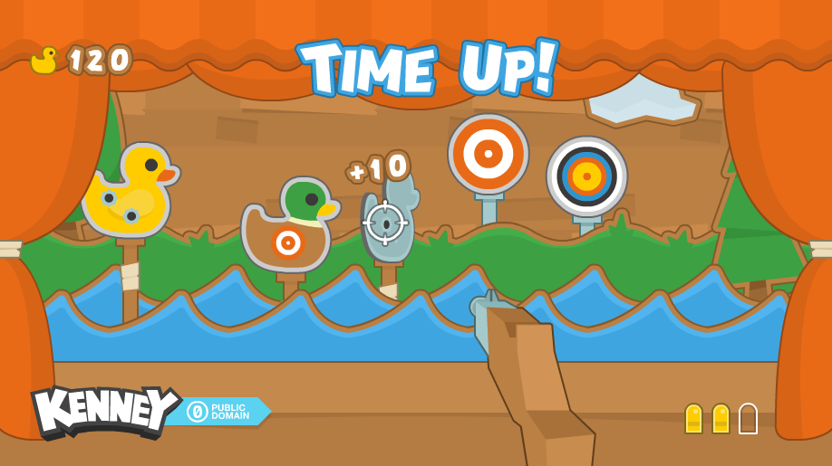Figure 3 shows a mock-up of how the assets given could be used, however the game that was designed for this project uses a simpler user interface and design. The figure also shows how the simple design and bright contrasting colours allows for clear and easy indication for stimuli. The clear indication is essential for the game, as the stimuli must be obvious to the point that it cannot be considered as a mitigating variable during testing, and that it assures the functionality of a stimulus.

Figure 3: Example of the shooting game assets (Kenney 2018)

## Driving Game Design

The next game that was created was the driving game. The concept for this game was for the player to follow along a track, and when prompted to tap either side of the screen to change the direction that they are travelling. There are 3 different direction types that can occur, which are left, right, and split. When left or right appear, the player must tap on the corresponding side of the screen to change to that direction. The next direction will be the opposite of the previous in order to bring the player back to the middle of the road. When the next direction is split, the player can choose to go either left or right, but then the same concept applies where they must re-join the middle of the road.

The driving game is intended to be a slight increase of difficulty over the previous shooting game, by adding the chance of a game ending prematurely if the wrong direction is chosen. This means that the player must make a decision before reacting. The results of this can then be correlated between how quickly someone reacts and how long they last within the game before making a mistake, which is translated by recording how long the player lasts while playing the game. The direction is not always random, as the direction change required from the player will be known for every other direction change that occurs, due to the course always returning to the centre. This keeps the game from being too difficult, as well as allowing for the controlling of values, and not having extreme cases causing anomalies during testing.

The response calculation for the driving game is defined from between when the next direction that occurs is displayed on screen, to when the player taps on either side of the screen to choose their direction. The direction is given in the form of text, in bold, in the middle of the screen. Instead of this indicating a direct action for the game, these stimuli indicate to the user that a decision needs to be made, which is how the difficulty is increased, and how the objective to test the user’s decision-making skills is implemented.

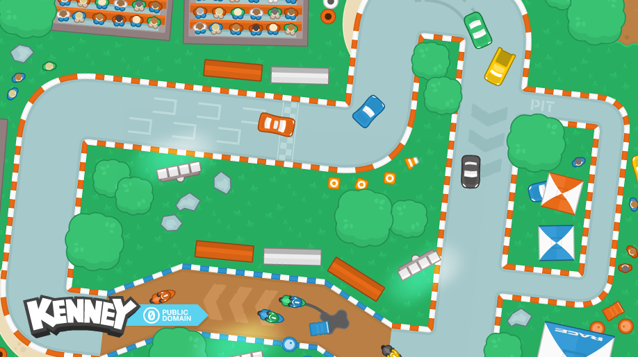Figure 4 shows a sample of a potential design using the assets chosen, but in the same fashion as the shooting game, a simpler design choice was made in order to declutter the screen, and make sure the stimuli was as clear as possible. This is why a clear and bold font in a contrasting colour to the background works, to clearly indicate when the stimulus occurs.

Figure 4: Example of the driving game assets (Kenney 2018)

## Dodging Game Design

The final game that was designed was the dodging game. This game was designed to be the most difficult of the three, and therefore had to include the most amount of player decision interaction. The aim of the game is to dodge the incoming asteroids, but this can only be done in one move with a single tap. The directions of the asteroids appear on screen, and the user must use this information to make a decision and to move the ship as quickly as possible. The player can move the ship to any position they choose, but can only do it once. The benefit of having the free movement of the user in the game means that the position of the taps is completely free choice, allowing for the clearest demonstration of handedness and its influence on tap position. Between one and three asteroids can appear at once, so when there are more, the moves that are possible for the player to make are decreased. As the asteroids get closer, the number of possible moves also decrease, meaning that the response time of the user is critical.

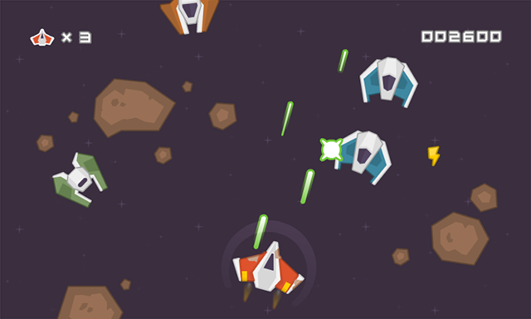The stimuli for the dodging game are the arrows that indicate the direction of the asteroids path. This means that when the arrows are shown, the player knows the direction and origin of the asteroids, and can therefore make a decision on where to move in order to dodge the asteroids. Using the reaction of the player, the reaction time is calculated from between the arrows appearing and the user reacting.

Figure 5: Example of the dodging game assets (Kenney 2018)

Figure 5 illustrates the assets of the dodging game used in context, yet to follow the design of the previous two games, the final game has a simpler design. The indicators for the direction of the asteroids appear as arrows around the ship, and they point towards the ship from the direction of the asteroid. The arrows were chosen to be white to contrast the dark background, making them distinct.

With the increased difficulty in the game, it is assumed that the time that players will last while playing the game should be smaller than the previous one. However, with the added pressure of difficulty, the desire is to induce a more urgent response from the user, which would exemplify the effect that more intense action games have on the user. This increase of difficulty across the games is expected to show a decrease in reaction times across the games (i.e. an improvement in a person’s performance).

# Development Methodology

## Development Overview

To develop the application, Unity (2019), a vast and powerful game engine was used in conjunction with C# as the coding language, and Android (2019) was the target platform for the application. However, the application also runs on Windows (2019).

Since the design choices had been made, including the use of the assets from Kenney, the development of the games’ implementation could begin straight away.

The title screen was made first, as this is where the user can access the three games. The identifier for each user is also set on this title screen. To access games, there are 3 buttons that the user can press to enter the game scenes. Since the application was designed to have very little input from the user, the simple UI chosen required only a small amount of interact ability. The only other button visible on the title screen is the identifier selector. When pressed, this button shows a dropdown list where the supervisor for testing can select the right identifier, and also a button that allows for the supervisor to create a new identifier file for user data to be assigned and saved to.

Each game also uses the same system to record the reaction time of the player, which is engrained into each game differently due to their varying nature. When the stimuli are shown to the player, the game starts to record the time that it takes for the player to make an input. When this time is recorded, the exact location of the input is also recorded. Then, at the end of the game, the best, worst, and average reaction time is calculated and stored along with the total time played for that session. The data is stored into a JSON file that is associated only to that user by using the current identifier that was assigned before starting the session. This data was then analysed and evaluated after the testing was complete.

## Shooting Game Development

The first game that was developed was the shooting game, as this had the simplest concept, but it was also the most important game, because this was the only game where the user could not fail. This assures that a full sample of data was collected during every test. As every test would span the whole time, each playthrough needed to be similar to the last, yet still random. This meant that the inclusion of controlled random target locations and target multiples was crucial. In order to do this, every variable that was randomised had to be defined beforehand and shuffled when the game began. Consequently, every playthrough will be somewhat similar to the last, but still completely random, so that patterns could not be detected. With this implemented, a timer could be set up that can countdown until the end of the game. This timer compensates for the time in between spawning phases of targets, as well as an exaggerated user reaction time. This means that every user will get a chance to hit every available target, but if their reaction time is considerably too slow, the game will cut short before all of the targets could be hit; this is very unlikely and is just in place in order to control testing time.

One of the random but controlled variables is the locations. These locations are stored as a struct, with a reference to the game object, a Boolean that defines whether the location has been used, and the location’s position. There is then a list of every possible location within the game, which is defined as the game starts. Then as the game goes through, targets are spawned in one of these positions randomly, but when a target is hit by the user, that location is then set to used and cannot be used throughout the rest of the game. There are three separate lists of locations for each type of spawn: single, double, and triple spawns. This means that if a single target is hit in one location, a double target can still spawn in that location. The locations are only set as used for the same type of spawn, not restricting the use of the locations between spawn types. Furthermore, if a double or triple spawn occurs, it is set so that at least one target must appear on either side of the screen, which is used to embellish the testing for handedness, and to further control the randomness of the locations.

Figure 6 shows an example of the shooting game in session. The UI is basic and clear to indicate how much time is left in the game, as well as the contrast of colours to increase the visibility of the targets themselves. It should also be noted that the device vibrates when a target has been hit, to confirm to the user that a valid response has been accepted.

Figure 6: An example of a shooting game session

## Driving Game Development

The driving game was the next game that was developed. The core design of the game uses sprite tiles as the road, which were formed into larger sections of road that correlated to 4 different states of the game: middle, left, right, and split. The middle is the default state of the game; the road always returns to the middle after being diverted. Left and right are the sections that the player must move to when prompted by the stimuli, and the split section is where the player can choose either side to move to, but must return back to the middle when the section ends. The car moves only if an input has been made, and when the car hits the trigger section (which is defined by using box colliders within Unity) of the road. If a movement has not been made before this trigger point, the game will end, as it does if the wrong direction has been selected.

As the games are all in the same vein in regard to controlling the variables of the randomised sections, the road directions and the lengths of the road sections are all predetermined, which allowed them to be stored using predefined arrays. These are shuffled when the game starts. There is a fixed number of each section, as well as a fixed number of lengths, which are shuffled at random to give each session a random order, but with a fixed overall outcome, therefore controlling all variables and denying the ability to notice patterns.

The nature of the stimuli for this game works differently to the shooting game, as the stimuli tells the user information, rather than giving a target to hit. This means that the response time has to be calculated by only recording the time between a direction being shown, and a valid input being made to the game. This is done by only allowing the user to interact with the game at a set time between the direction being displayed and the first input being made. The fact that the user has to process the information before reacting also augments the difficulty, as they must make a decision before reacting. If they make the wrong decision, the game will end and the testing for that session will be cut short. This loss of time can be stored however and can be compared to other users and subsequent test sessions that the user has undertaken.

Figure 7 below shows an example of the driving game being played, where the player is currently in the split position, and is being prompted to move back to the middle. It is at this point that the player would be required to tap the right-hand side of the screen as soon as that prompt was shown. The stimulus is in an easily legible font in a contrasting colour, and the device will vibrate when the user has responded to the stimulus.

## Dodging Game Development

Figure 7: An example of the driving game in session

The final game that was developed was the dodging game. The aim of this game is to dodge any incoming asteroids using only one move. The player starts in the middle of the playing area and arrows appear around the player’s ship as soon as the asteroids spawn. These arrows are activated depending on the origin of the asteroids, and indicate the path on which the asteroids are travelling. These arrows are used as the stimuli for this game, and in a similar sense to the driving game, they provide information for the user to interpret and react to. However, to increase the difficulty further from the driving game, the stimuli is not an instruction and is only information indicating the direction of the asteroids, therefore requiring more tasking engagement from the user. Once the player has made their decision, they can tap on the screen once to move to that specific position. This complete freedom of movement also increases the responsibility of the player by forcing them to make their own decision, increasing the complexity and difficulty.

The controlled variable in this game is the number of asteroids that spawn at once. There can be between one and three asteroids that appear, but the number of these is predetermined in an array, which is shuffled as the game begins. As soon as the asteroids spawn, the correlating arrows will be shown to indicate the paths of the asteroids; these are the stimuli for this game. The arrows are always shown in a set perimeter around the ship, as the asteroids use the ship’s position to calculate where to spawn. The response time is recorded from between when the arrows are shown and when the user makes an input. If the player fails to make a movement that avoids the asteroids, the game will end upon collision, otherwise the game will carry on until the timer runs out.

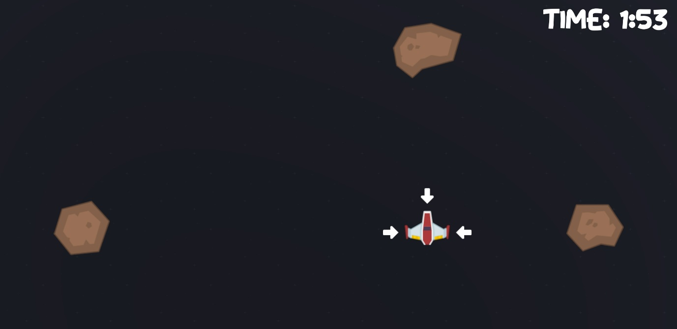Figure 8 shows an example of the dodging game being played. It shows an instance where the player is shown the paths of the asteroids and must make a movement in order to dodge them. The arrows are a contrasting colour to the background in order to clearly indicate the stimuli, and the device will vibrate when the player taps to move the ship.

Figure 8: An example of the dodging game in session

# Testing Methodology

## Testing Overview

The testing was carried out upon completion of the application. Before starting the games, each participant provided two small pieces of information in order to compare the results after testing: their age, and their dominant hand. The user will be set a unique identifier that is assigned by the testing supervisor. The participants will play each game two times consecutively, and then this procedure will be carried out three times throughout one week, with three days in between tests (e.g. Monday, Thursday, and Sunday). In order to allow the users to get accustomed to the games, a brief introduction and set of instructions will be explained before playing each game that details everything they need to know about how the games function. They will also be able to become familiar with the games, by being given the opportunity to play each game once on a build that does not record data, so that when they play the games for testing purposes, their results are only recorded when they have this prior knowledge and understanding. It is important to not only explain how the games function, but to also play the games to get a feel for the controls and to experience each game first-hand. This prevents the user from experiencing any unexpected scenarios, and clearly illustrates what is detailed in the brief.

## Controlling Variables

The games were developed in order to control all of the necessary variables, in order to control the results and make them valid. It is important to control variables ‘to clearly identify the relationship between an independent variable and a dependent variable’ (Carpi and Egger, 2009); the independent variable in this experiment being the different users testing the games, and the dependent variable being the reaction time from the user. The nature of the controlled variables in this application revolves around keeping each game session uniform to the previous, but also stopping the user from noticing any patterns in the gameplay by randomising the games’ stimuli. This therefore controls the variables by limiting the variations in stimuli production, yet randomising the variations to prevent the user from making any pre-emptive reactions. This process changes the variables from random to controlled by having only a limited number of scenarios that are possible, and that are not dissimilar to one another. Doing this also validates the experiment further when using these discrete random variables, as it imitates the reality of video games, which are rarely ever controlled to one hundred percent. With all of this under consideration, it allows for the data to be accurate in order to show any improvement over the course of the testing. These results are then compared to evaluate the application’s ability to improve the user’s reaction time.

The shooting game controlled the number of targets spawning (one, two, or three), and how the locations of the targets are spread out in order to not have a target spawn in the same place twice. It also prevented targets from spawning on only one side if multiple targets spawn, allowing for a proper evaluation of how handedness can affect reaction times. With these variables controlled, the dependent variable can be accurately measured, as each session should provide scenarios where the targets appear in similar but not identical situations.

To control the driving game, the number of direction changes and lengths of each section were controlled. This assured every session included an even number of directions (left, right, and middle), as well as having an even amount of distances for each section. This presents every session with random combinations of sections, but they are evenly distributed to keep the randomisation discrete.

Finally, the dodging game controlled the number of asteroids that could appear in the game at once (one, two, or three). When the number of asteroids increases, the difficulty increases, so in order to keep the game at a consistent difficulty for each user, this was controlled. Keeping the difficulty consistent assures the fact that each user will experience a similar session, not only from one to user to the next, but from between testing sessions.

## Expected Findings

After the testing is complete, there are predictions for the outcome of the results. An overall improvement of reaction time across the users should be found, assuming that the research that was carried out during this project is accurate. An overall increased length of playing time in the driving and dodging games should also be found, as the user should become more and more competent after a series of play-throughs. The results will also allow for a couple of discussions using the data provided from each user. It will be possible to see how age influences reaction time, and whether or not there is a larger room for improvement if their response time starts slower than average. It will also be possible to see how a user’s handedness preference can influence the positions of the taps within the shooting game. When all the testing is done and the data is stored, it will then be possible to make a judgement on how action games and their concepts can have an effect on the user’s response time.

# Testing Results

## Reaction Time Results

Now that the testing is complete, the data that has been recorded can be analysed. The data has been retrieved from the JSON files where it was stored on the device and has been organised into tables for each testing session. The tables display the best, worst and average response times from each user for each game, as well as the total time that each session lasted. The data is shown in seconds, to three decimal places to show a clear but precise amount of detail, however the data was stored at 15 decimal places to assure optimum accuracy.

Figure 9: Test 1 data

Figure 9 shows the data collected from the first test. This data is used to set a precedent for the rest of the results. This table shows how the core data was stored and how the data can be compared to the other tests. It also displays the data associated with each user’s identifier, and also displays their age to get an understanding of the user that is associated. The indication of user age ranges can then be compared to get an understanding on whether performance is directly related to age.

Figure 10 shows the data that was recorded from the second test. Here we can start to compare the results to see if there are any improvements. Immediately, it can be seen in the shooting and dodging games that there has been an overall decrease in response times when averaged out across the users. It can also be seen that the time spent playing both the driving and dodging game has increased, meaning that the users’ reactions are improving in order to prevent them from failing these games early. The time spent playing the shooting game has also decreased, further confirming the decrease in overall reaction times. This is implied because there is a finite number of targets to hit for each session, and therefore shows that the user is hitting all of these targets in a shorter period of time.

Figure 11: Test 3 data

Figure 10: Test 2 data

Figure 11 shows the final test’s data. This test also shows a further improvement on reaction time across users. What can clearly be seen in the last test is that 75% of the users managed to complete the driving and dodging game, which is a large improvement over the 45% that finished these games in the second test, which was also an improvement on the completion rate of 25% in the first test.

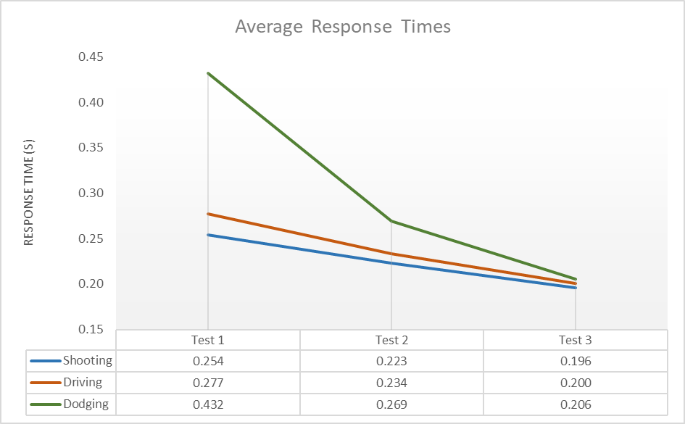Figure 12 breaks down the core information gathered from the three testing phases. In all three games, there is a clear reduction of average response times over the three testing sessions. There is also a dramatic increase in session time in both the driving and dodging games, which shows a correlation between the two factors of a decreased response time and increased session time. This is reaffirmed by the fact that the session time of the shooting game decreases as the response time decreases, which means that the reaction times must be faster throughout the whole game session in order to finish it earlier than the previous tests. The fastest response also improves over the testing phases; however, the slowest response does not show any clear correlation throughout the tests.

Figure 13: Response time graph

Figure 12: Test data averages comparison

Figure 13 clearly illustrates how the response time over the testing phases decreases in all three games, with the largest decrease being shown in the dodging game. It can also be seen that the response time for all three games seems to reach a remarkably similar point, with only one hundredth of a second between the three games’ average response times, averaging around 200ms.

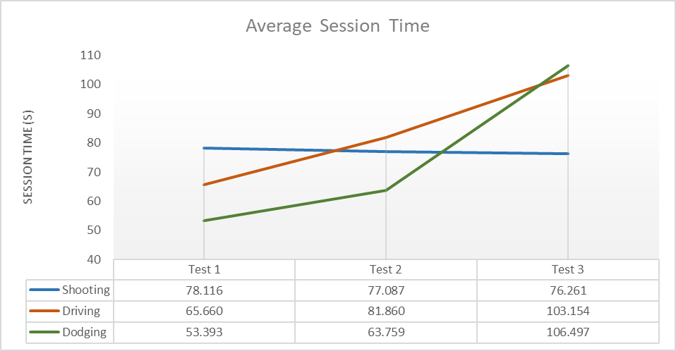Figure 14 displays the relationship between the length of reaction times between the games. The shooting game travels in the opposite direction as the intention of the shooting game’s timer is to have the opposite effect to the driving and dodging games. This is because a faster completion time in the shooting game confirms an improvement in the reaction time.

Figure 14: Average session time graph

## Age Influence on Results

Figure 15: Average response compared by age

Figure 15 displays the average response times for the users, labelled on the y axis by their age. This shows that there is no clear correlation between age and response time, except that the oldest users of age 79 and 81 have the two slowest response times. This could be assumed by their age, however there is not enough data to confirm this, so this will not be investigated further. This concept would however be an interesting consideration for a future investigation, as a larger data pool could show a clearer correlation.

## Handedness Influence on Tap Position

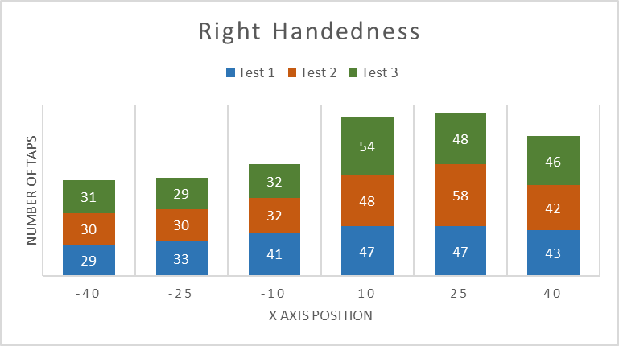The shooting game was designed in order to analyse how the position of taps could be influenced by the user’s handedness. It also recorded the response time for each tap, so the position of the tap could be compared to its individual response time.

Figure 16: Right handedness graph

Figure 16 displays the tap positions that were made by every right handed user throughout all of the tests. It is clearly indicated that the right handed users preferred to tap on the right-hand side of the screen. This was also consistent throughout all three testing phases.

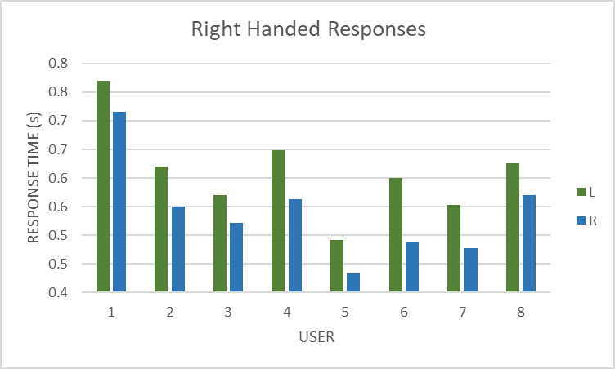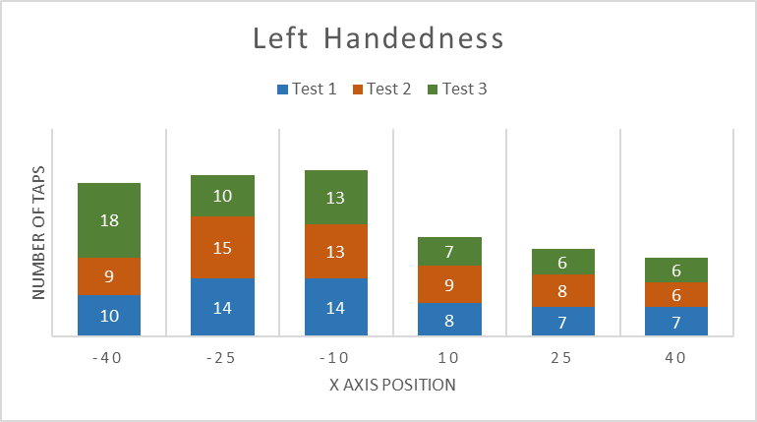Figure 17 shows the tap positions made by the left handed users. This set of data concurs with the right handedness data, as the left handed users preferred to tap on the left-hand side of the screen, and this was also consistent throughout all three testing phases.

Figure 18: Average responses of right handed users

Figure 17: Left handedness graph

Figure 18 shows the average response time of each right handed user, separated by the tap positions of the left and right sides of the screen. For every right handed user, the responses made on the right-hand side of the screen were faster than on the left.

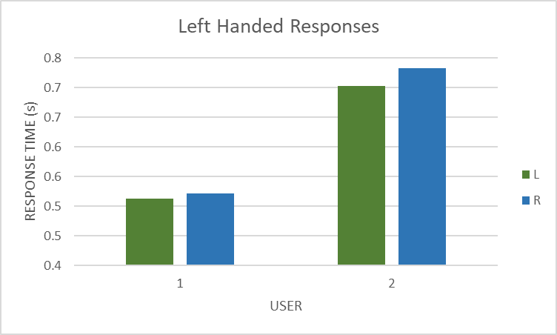Finally, figure 19 shows the data stored for the two left handed users. In both instances, the responses made on the left-hand side of the screen were faster than on the right. Thus, concluding that the tap position on the screen correlates to a faster response time from the respective dominant hand of the user.

Figure 19: Average responses of left handed users

# Results Discussion

## Reaction Time Evaluation

The results that were found allow for various conclusions to be made. The main discovery and the main aim of this project was that the average reaction time of all of the users decreased across the three games. From the literature that was surveyed earlier in this project, it was claimed that the use of action video games can improve reaction time, and the results from the testing seem to concur this conclusion.

The average of all the users’ reaction times improved, suggesting that the use of video games having the ability to decrease reaction times to a similar response time that has been ‘found in traditional laboratory studies’ (McLeod, 1986); a time of 200ms. These results could also suggest that the use of action video games was a valid decision, as the improvement on reaction time concurs with the literature as discussed in the background theory. As action games specifically require ‘rapid processing of sensory information and prompt action’ (Dye, Green, and Bavelier, 2009), it is suggested that the limited time granted to the user for a response inherently promotes a faster response. From there it could be concluded that the repetitive nature of the testing generates an understanding within the user, that they must respond as quickly and be as focused as possible in order to respond with a fast and accurate action, permitting the game to continue. If they were not able to react succinctly, they would be punished with the words ‘Game Over’ illustrating a clear understanding of failure.

What could be considered as a consequence of the reaction times decreasing, is the average length of the driving and dodging games increasing. A correlation between these two can be drawn, as when the average users’ response is faster, they have more chance of progressing through the game session. This improvement was made over the course of the three tests, and could therefore be associated with practice aiding the improvement. Ross claims that ‘physical and mental practice can actually produce improvement in performance’ (1985), concurring with this conclusion. As the user plays the game more, their understanding becomes more detailed, allowing the user to make more precise decisions. This is due to the perceptions made throughout the sessions, which presents the user with the limited number of scenarios that can occur throughout the games. This then decreases the possibilities that the user needs to consider when anticipating the next stimuli that is presented. From this it can be understood that practice is essential, and directly correlates to success in the driving and dodging games. Furthermore, this could suggest that the practice also has an influence on the reaction time of the user, as the limited number of scenarios that are presented to the user can be more easily anticipated with extended use. Thus, the decision making required from the user is decreased, allowing for a faster decision and input. This conclusion could be considered for a further investigation that considers whether it is the skill of the player that is improving over their reaction time, rather than just their reaction time.

## Handedness Evaluation

Handedness was shown to have a clear influence on the reaction times of the user, as the graphs illustrated how the dominant hand achieves a faster reaction on the respective side of the screen. As the shooting game presents scenarios with multiple targets that the player must choose between, this allowed for the evaluation of handedness preference, as the player would play the game with two hands, and the targets would appear on either side of the screen. In every user tested, their dominant hand displayed a faster average reaction than their weaker hand. This is explained by Goodin et al. (1996) who claims that for both left and right handed users, the act of anticipation of a stimulus to respond to displays not only a clear ‘preparation to make a particular response but also a preparation to process the stimulus’. This confirms the findings from the testing as the user would make a response using their dominant hand first, and if that is not applicable, only then to respond using the opposite hand.

## Results Evaluation

From these evaluations, it seems clear that video games can play a significant part in improving the reaction times of the user. The results show conclusive evidence that just a small amount of repetitive use of the application can improve the average reaction time within the games. Using this evidence, it could be applied to other scenarios regarding reaction time, and the games could be used as an aid to improve them. An example of an application could be using simple mobile phone action games to improve the average driver’s reaction time. Quimby et al. (1981) discussed the variables that contribute to a driver’s safety, with reaction times as well as ‘visual and perceptual abilities’ being large factors of driving performance. Furthermore, the handedness evaluation could be considered for research, as Coren (2011) found that left handed people ‘were more likely to report having an injury’ than right handed people as a general rule. These results could be used to develop a game related application that could be used to improve the reaction times of the non-dominant hand, encouraging the reduction of negative real-life scenarios that involve the non-dominant hand.

# Conclusion

## Application Evaluation

The application that was designed and developed for the sake of this study managed to succeed in its original aim; however, this wasn’t without certain shortcomings. Each game that was developed met the initial design specification that was laid out prior to its generation. They also each managed to improve the reaction times of the user, which was the original goal of the application. The designs were simple and easily understood by the users, with any confusion being quickly eliminated by a single playthrough of each game. The application was also clear and concise, easy to navigate, and displayed only the relevant information to the users, while hiding the necessary data to not influence the responses of the user. The results that were stored was also extensive enough to produce plenty of data that could be analysed in order to come up with the evidence that was found.

The application did include some minor bugs that were only realised after the testing had begun. One example occurred in the driving game; if the user tapped twice quickly in two different directions, the last input would be taken and not the first. As soon as this was realised, as the game was supervised, the users were advised to only tap the direction once, which each user made sure to do and therefore this did not affect with the results. Another bug that was found was that the first identifier (ID: 0) could not be used when testing, and was therefore omitted from the testing, and the users were assigned the successive identifiers.

There were also some limitations that were considered during the development. The processing time of the device that was used to record the data was understood, however this time was so small that it was deemed immaterial and was disregarded in the time calculations. Similarly, the difference in latency caused by this processing time would have been insignificant when compared across testing sessions. Another small limitation was that the development did not consider the ability to store data for multiple testing phases, and therefore four builds needed to be created for testing purposes: a practice build, and the three testing builds. Each build then stored its own data separately, however this did mean that each build was identical to the last, and that it reduced discrepancies in processing power required to play by having limited storing functionality.

One improvement that could have been made if time permitted, was that multiple types of stimuli could have been added to the game and tested throughout the phases. Auditory and tactile stimuli could have been extra additions, and could have been analysed to see if it had any effect on the response time of the user. These stimuli would have been added so that they occurred at the same time as the visual stimuli, but as Ng. et al discussed, they may have decreased the reaction time as both auditory and tactile stimuli is claimed to generate faster reaction times than visual stimuli.

Some other improvements could have been made to make the games more applicable in a commercial environment. A benefit of having the game appeal to a more commercial market would be that it could be used to improve the response time of any user that obtained it, rather than just the test subjects. A way this could have been considered is to include an alternative gameplay mode that would be much more random, and include more varied and intensive gameplay. This would engage the user more, and encourage them to use the games on a daily basis, thus improving their reaction time in conjunction with experiencing enjoyment from the game. As discussed in the results evaluation, this could benefit society by decreasing the risks of daily activities via these improved response times.

## Project Analysis

The initial goals of this project were achieved thanks to the development of the application; the study itself was a crucial element to these findings.

The literature review that was undertaken at the beginning of the study helped direct the course of the project. It influenced elements such as using the correct device to gather the data, which then led to the development of the application being made for a mobile device. This also gave the ability to bring the testing device to the users, rather than bringing the users to the device, with the portability benefitting the testing scenario greatly. It also initiated the understanding of action video games being the most beneficial video game type to utilise, leading to the design direction of the games.

The testing process was also crucial to the project, as the process that it was carried out under gave controlled and detailed results. The combination of the mobility of the device and the testing process also increased the number of testing subjects that were available. Accurate results were gained from the testing, and therefore the analysis of the results was also crucial to determining the findings from this study. The graphs that were generated from the results also gave a clear understanding of the findings.

Some shortcomings of the project were the result of poor time management. The original estimate of the time it would take to develop the application was underestimated, limiting the volume of testing, which suffered as a consequence. A shorter amount of time was allocated to testing, which limited the quantity of data that could be analysed.

One limitation of the project also links to the time management and testing. If more test subjects were used, a much larger pool of data could have been analysed, which may have given results that could be considered more reliable and descriptive. However, the results achieved are incontrovertible. A much larger age range could have also been considered, which would have given a clearer understanding on how age affects response times, which was not conclusive in this study. There were also environmental and situational variables that were not controlled during testing that may have affected the results. Some examples of these variables are: how much sleep the user had, whether they were under the influence of stimulants (e.g. coffee), or how distracted the user was.

There are a number of improvements that could also have been made to this study; more types of data could have been considered during the development, which would have gained further evidence to the current conclusions, and additional findings could have been made. Some examples of these could have been how difficulty can change response time within the same game mode; how users react to different colours and whether contrast makes a difference; or whether having a visible leaderboard between users could have created a competitive element and whether that influenced the response time. Gender could also have been taken into account, and a difference between genders’ reaction times could have been analysed.

## Conclusion

To conclude, this project managed to show evidence that extended use of action video games can improve reaction times of the user. It suggested that age does not play a part in the improvement of reaction time, however all ages experienced improved reaction times, and the discovery of how handedness preference influences the reaction time was also made, as reaction times were better when the dominant hand was used. The quality of reactions was also analysed, and it was shown that practice can improve the skill of the user, by improving the accuracy and speed of said reactions. While there were shortcomings experienced during this project, the main objective was proven, and it showed that video games can have a positive influence on the human response, deeming this project a success.

# References

Dye, M., Green, C. and Bavelier, D. 2009. Increasing speed of processing with action video games. *Current directions in psychological science*, 18(6), pp. 321-326.

Whitham, R. 2015. *10 multiplayer android games where you share the same phone [online].* Greenbot. Available from: <https://www.greenbot.com/article/2876235/10-android-games-you-and-a-friend-can-play-on-the-same-phone.html#slide1> [Accessed 1 November 2018].

Ng, A. and Chan, A. 2012. Finger Response Times to Visual, Auditory and Tactile Modality Stimuli. *Proceedings of the International MultiConference of Engineers and Computer Scientists*, 2.

Statista, 2018. *Share of smartphone users in the United Kingdom (UK) from 2012 to 2016, by gender [online].* Google. Available from: <https://www.statista.com/statistics/732591/united-kingdom-smartphone-users-by-gender/> [Accessed 1 November 2018]

Statista, 2018. ***Share of smartphone users in the United Kingdom (UK) from 2012 to 2016, by age [online].* Google. Available from:** <https://www.statista.com/statistics/732535/united-kingdom-smartphone-users-by-age/> **[Accessed 1 November 2018]**

Kenney, 2018. *Kenney Bundle [online].* Itch Corp. Available from: <https://itch.io/s/6789/kenney-bundle> [Accessed 1 November 2018]

Ng, A. and Chan, A. 2012. Finger response times to visual, auditory and tactile modality stimuli. *Proceedings of the international multiconference of engineers and computer scientists*, 2.

Castel, A. D., Pratt, J., & Drummond, E., 2005. The effects of action video game experience on the time course of inhibition of return and the efficiency of visual search. *Acta psychologica*, 119(2), 217–230.

Orosy-Fildes, C., & Allan, R. W., 1989. Psychology of computer use: XII. videogame play: human reaction time to visual stimuli. *Perceptual and motor skills,* 69(1), 243–247.

Statista, 2018. ***Share of smartphone users in the United Kingdom (UK) from 2012 to 2016, by age [online].* Google. Available from:** https://www.statista.com/statistics/732535/united-kingdom-smartphone-users-by-age/ **[Accessed 1 November 2018]**

Colzato, L. S., van den Wildenberg, W. P. M., Zmigrod, S., & Hommel, B., 2012. Action video gaming and cognitive control: playing first person shooter games is associated with improvement in working memory but not action inhibition. *Psychological research*, 77(2), 234–239.

Greenfield, P. M., 1984. *Mind and media: the effects of television, video games and computers.* Cambridge: Harvard University Press.

Green, C. S., Bavelier, D., 2004. The cognitive neuroscience of video games. *Digital media: transformations in human communication.*

Greenfield, P. M., DeWinstanley, P., Kilpatrick, H., & Kaye, D., 1994. Action video games and informal education: effects on strategies for dividing visual attention. *Journal of applied developmental psychology*, 15(1), 105–123.

McLeod, P., 1987. Visual reaction time and high-speed ball games. *Perception*.

Green, C. S. and Bavelier, D., 2012. Learning, attentional control, and action video games. *Current Biology*.

Goodin, D. S., Aminoff, M. J., Ortiz, T. A., and Chequer, R. S., 1996. Response times and handedness in simple reaction-time tasks. *Experimental Brain Research*.

Quimby, A. R. and Watts, G. R., 1981. Human Factors and Driving Performance.

Carpi, A. and Egger, A. E., 2009. Controlling Variables. *Visionlearning*, POS-2 (3).

Boot, W. R., Blakely, D. P., and Simons, D. J., 2011. Do action video games improve perception and cognition? *Frontiers in Psychology*.

Microsoft, 2019. *Windows* [online]. Available from: https://www.microsoft.com/en-gb/windows.

Samsung, 2019. Galaxy S9+. [online]. Available from: https://www.samsung.com/uk/smartphones/galaxy-s9/.

Technologies, U., 2019. *Unity* [online]. Available from: https://unity.com/.

Google, 2019. *Android* [online]. Available from: https://www.android.com/intl/en_uk/.

# Appendices

Graphs and Tables



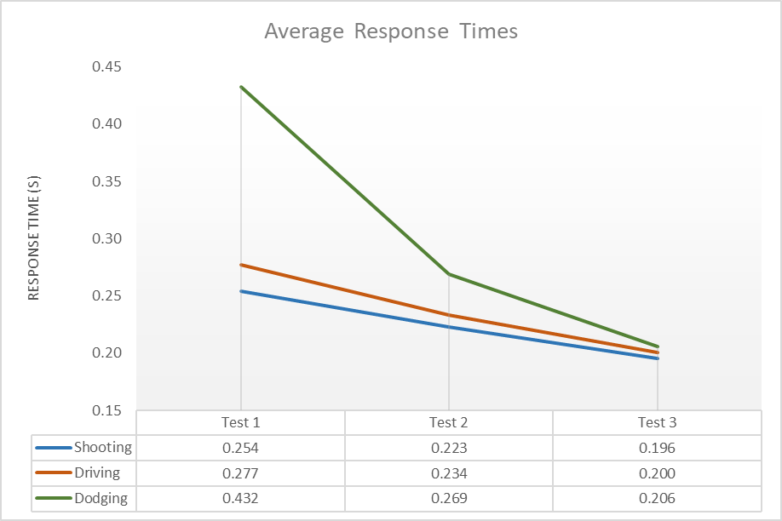

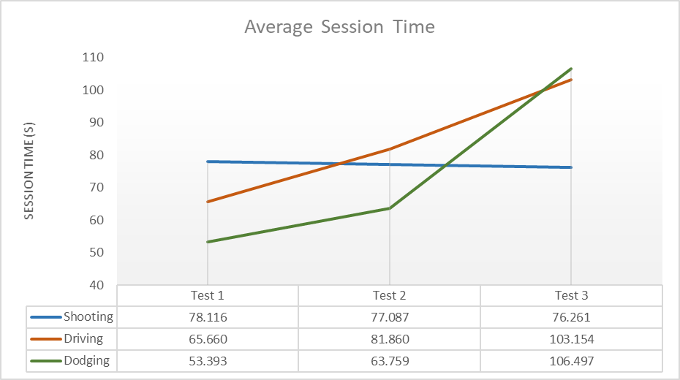





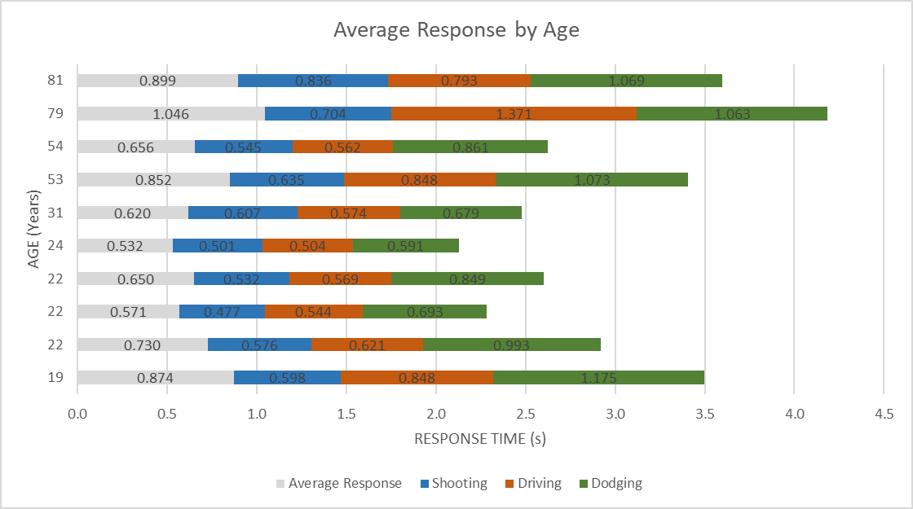

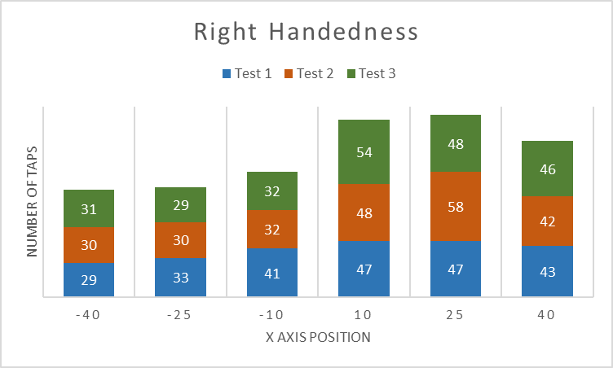

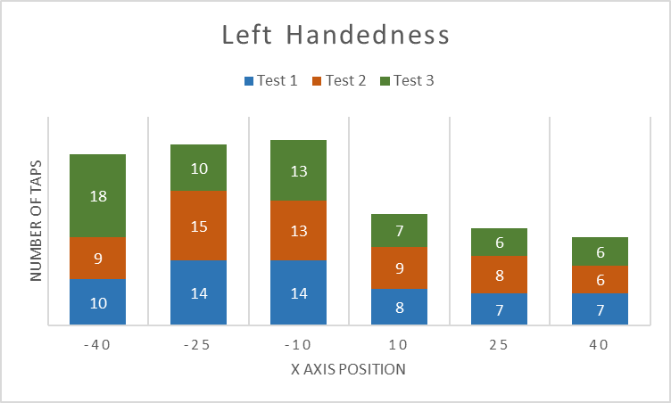

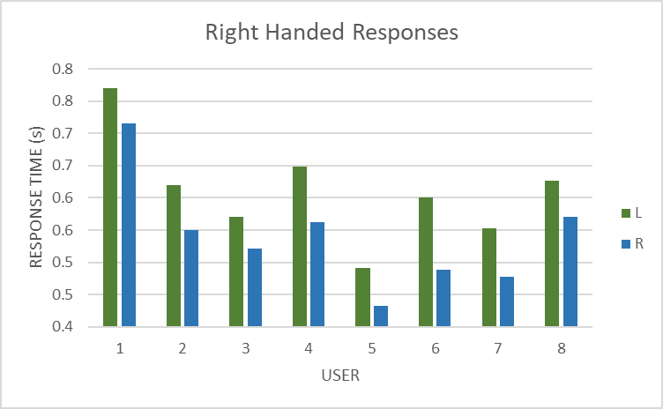

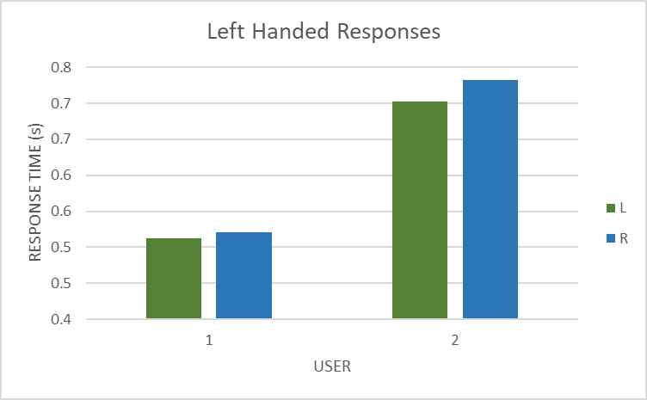

Ethics Checklist







Participant Questionnaire

Participant Questions:

What is your age?

__________________

Which is your dominant hand? (Please circle one)

L / R

To be filled out by the Researcher:

ID Number: ________